A
PROJECT REPORT ON
rythm
(A Music Website)
By

Devendrakumar Raiyani (CE-107) (17CEUOG022)
Milan Prajapati (CE-102) (17CEUBG027)
Kumar Sondarva (CE-129) (17CEUSG032)

B. Tech. CE Semester-VI
Subject: System Design Practice

Guided by: Prof.Pandav K. Patel
Assistant Professor Dept. of Comp. Engg.


Faculty of Technology
Department of Computer Engineering
Dharmsinh Desai University

Faculty of Technology
Department of Computer Engineering
Dharmsinh Desai University

CERTIFICATE

This is to certify that the practical / term work carried out in the subject of
System Design Practice and recorded in this journal is the bonafide work of
Devendrakumar Raiyani (CE-107) (17CEUOG022)
Milan Prajapati (CE-102) (17CEUBG027)
Kumar Sondarva (CE-129) (17CEUSG032)

of B.Tech. semester VI in the branch of Computer Engineering
during the academic year 2019-2020.

Prof. Pandav K. Patel Dr. C. K. Bhensdadia,
Assistant Professor, Head,
Dept. of Computer Engg., Dept. of Computer Engg.,
Faculty of Technology Faculty of Technology
Dharmsinh Desai University, Nadiad Dharmsinh Desai University, Nadiad

CONTENTS

1. Abstract……………………………………………….4
2. Introduction.…………………………………………..5
2.1 Brief Introduction ………………………..5
2.2 Technology/Platform/Tools Used …………5
3. Software Requirement Specifications……….……...6-7
4. Design……………………………………....…………8
4.1 Use Case Diagrams……..……….………8-12
4.2 Class Diagrams..………………..………….13
4.3 Sequence Diagrams………………………..14
4.4 Activity Diagrams………………………....15
4.5 State Diagrams…………………………….16
4.6 E-R Diagram....…….…………...…………14
4.7 Data dictionary….……………………...15-16
5. Implementation Detail………………………..…………17
5.1 Modules …………………………………...17
5.2 Functional Prototypes ……………………..17
6. Testing…..…...……...……...……………….……18-20
7. Screen-shots….………………………………..….21-27
8. Conclusion...…………………………………….……28
9. Limitation and Future Extension…...……………...…28
10. Bibliography……………………………………...…..29

ABSTRACT

Music plays a very important role in human’s daily life and in the modern advanced technologies.
It is online music web application which provides user functionality of playing songs. User can also view the playlist created by Admin and play songs from them. User can also download song (free of cost). User can Sign up Login the website using his/her email. And if user is logged in he/she can like the song(s) and that songs will be added to their respective “favourite” and the can access it from anywhere.
Admin will be managing the songs, playlists, and Genre of songs.

- Developer Team
(Devendrakumar, Milan & Kumar)

INTODUCTION

Our Project topic is Music World. We have developed this site for users’ satisfaction. Now a day’s Music has held an important place in people’s lives.
The main aim of this music world site is to manage the details of the music, customer, album type. It manages all the information about music, track, album type, music. The project is built at administrative end and thus only the administrative is guaranteed the access. In this project user can play and listen songs and even download the songs without any cost but for that user must have account in this website. in this website users can select any playlist and song list will be displayed. By selecting any song from the list, song will be played and audio player will be displayed at the bottom of the window with song title. And also, there is like button user can press that button and particular song will be added in favorite playlist of the user and if click it again then song will be removed. User can also have songs filtered through category (Genre) of songs. User can also see the recently added (20) songs.
Here the admin is responsible for managing the songs, playlists and categories. Admin can also remove any song, playlist, and category. Admin can also view the statistics of the application like total no of songs, playlists, categories, and total songs in the respective Category.

Tools/Technologies Used
Technologies: HTML5,
CSS3,
Bootstrap4,
Angular cli,
Typescript,
Node JS,
Express,
Multer,
Mongo DB

Tools: Visual Studio Code,
MongoDb Compass,
Browser

Platforms: Windows,
Linux(Ubuntu)

- Developer Team
(Devendrakumar, Milan & Kumar)
SOFTWARE REQUIREMENT SPECIFICATION
for
rythm

- User log in :-
Description: If users want to log in or sign up then users can do that. Users can log in or sign up by email id. Users can still accesses the home page without login or sign up.
Input: User enters email id.
Output: Successfully logged in message and home page.

- Home Page:-
Description: It contains search, user menu, queue buttons and various play lists like New Released, Film Album, Recently Played (If user logged in), Hit Songs, Romantic Songs, Artists Albums and other albums generated by admin.
R2.1 Search:
Input: Song Name
Output: Results of Related Songs
R2.2 Play Lists:
Input: User selection
Output: All songs of that play lists
R2.3 Queue of Songs:
Description: User add songs in queue to listen songs in sequence.
Input: User selection
Output: Show queue songs
R2.4 User Menu:
Description: If users logged in then they can see their details and log out button.
Input: User Selection
Output: User details, User's Play lists, User's favourite songs, Log out button.

R3. My Play Lists:-
Description: Users can create their own play lists by selecting songs from different playlist after logged in.
Prerequisite condition: User must be logged in.
Input: User Selection of songs
Output: Successful message

R4. My Favourite:-
Description: Songs liked by user are shown here.
Prerequisite condition: User must be logged in.
Input: User Selection
Output: Display Songs

R5. Play Song:
Input: User Selection
Output: Play song
R6. User Access to Songs:-
Description: Song Details such as name, duration, artists name, number of likes, number of time played. User can download, share songs and like song.
Input: User Selection
Output: Song will be played, details of song.
R6.1 Like Song:
Prerequisite condition: User must be logged in.
Input: User Selection
Output: If user is logged in then they can like otherwise redirected to log in page
R6.2 Download Song:
Input: User Selection
Output: Downloading will be started
R6.3 Share Song:
Description: User can share song via email or can copy link of song.
Input: User selection
Output: Successful message

R7. Feedback:-
Description: User can give general feedback by email without logged in.
Input: User details and message
Output: Successful message

R8. Admin Panel:-
Description: Admin can manage songs, view general statistics, manage feedback.
R8.1 Manage Songs:
R8.1.1 Add Song:
Input: Song Details and upload mp3 file of song
Output: Successful message
R8.1.2 Update Song:
Input: Change Song Details
Output: Successful message
R8.1.3 Delete Song:
Input: User Selection
Output: Successful message
R8.2 Manage Playlists:
R8.1.1 Add Playlist:
Input: Playlist Details and selection of at least one song
Output: Successful message
R8.1.2 Update Playlist:
Input: Change Playlist Name and Remove or Add songs to playlist
Output: Successful message
R8.1.3 Delete Playlist:
Input: User Selection
Output: Successful message

R8.3 Manage Categories:
R8.1.1 Add Category:
Input: Category Name
Output: Successful message
R8.1.2 Rename Category:
Input: New name of category
Output: Successful message
R8.4 General Statistics:
Description: Admin can see total likes, total songs, total visitors.
Input: User Selection
Output: Display Data

DESIGN
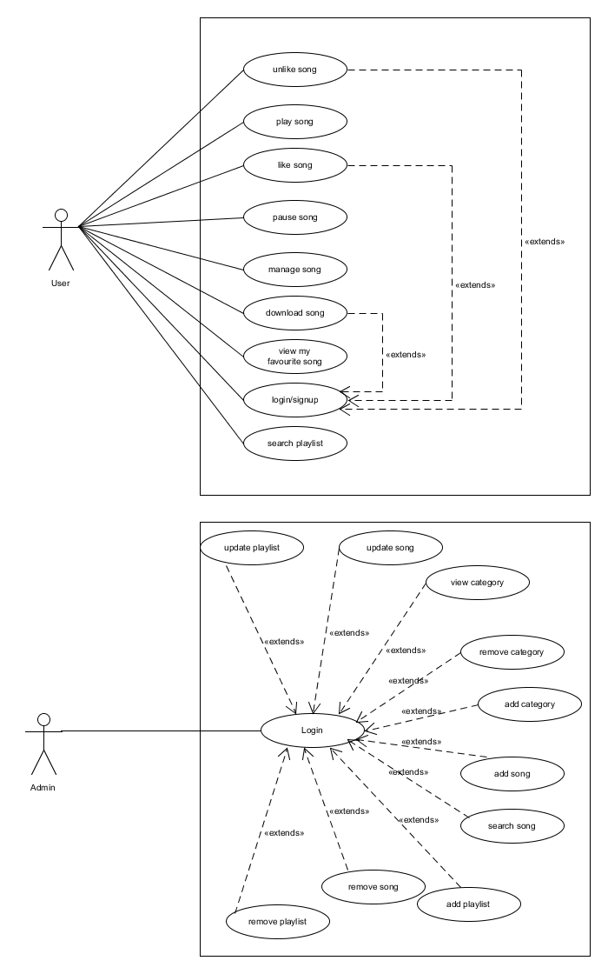
- Use Case Diagram:

- Class Diagram:
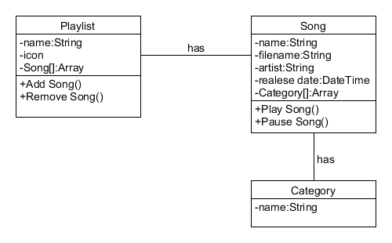

- Sequence Diagram:
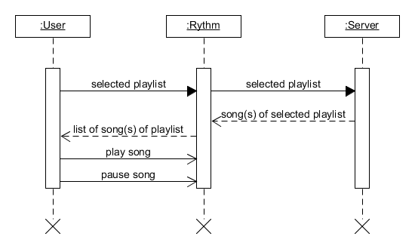

- Activity Diagram:
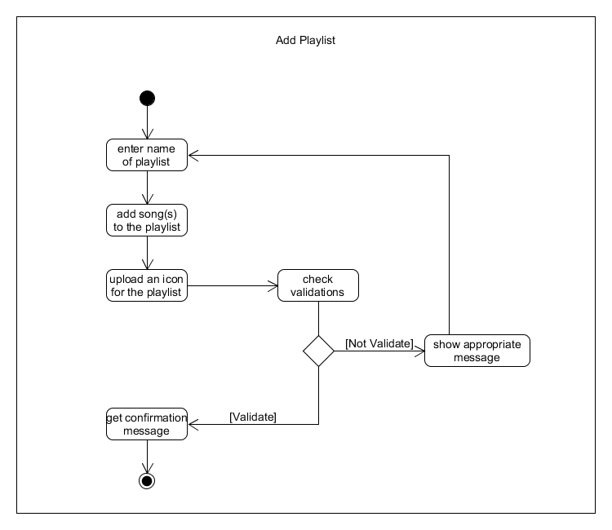

- State Diagram:
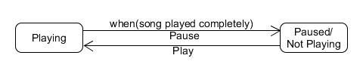

- E-R Diagram:

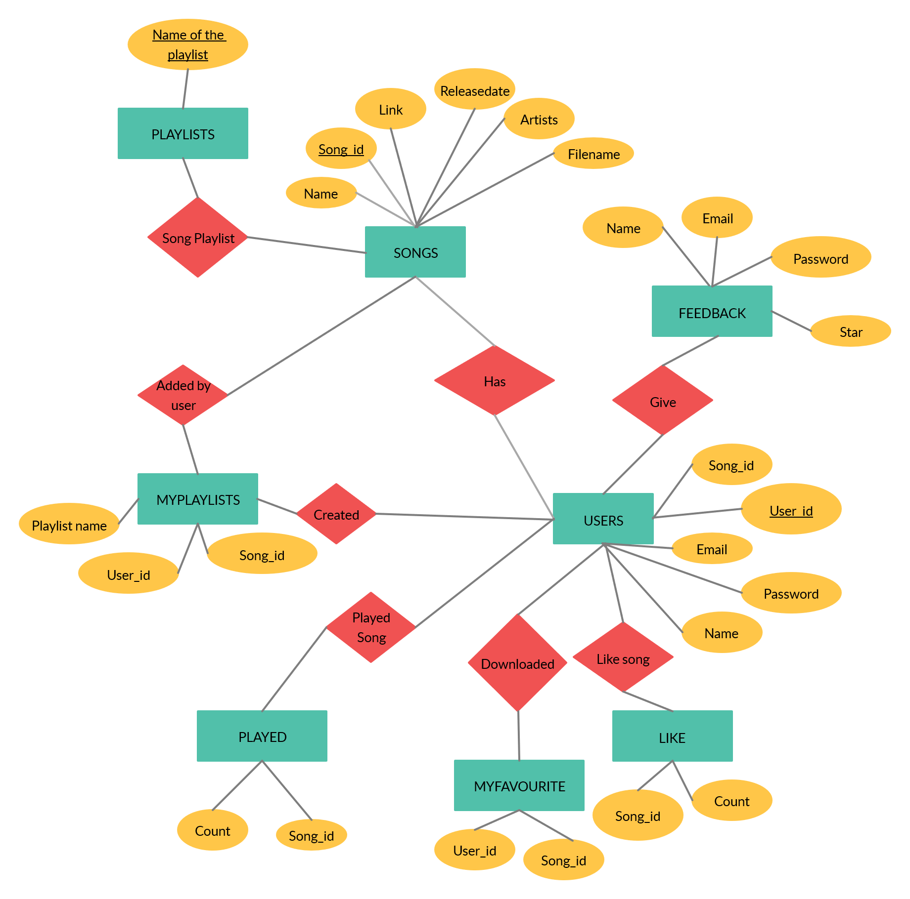
- Data dictionary:
1)
Feedback
Sr. No. | Field Name | Data Type | Width | Required | Unique | PK/FK | Referenced Table | Description
1. | name | varchar2 | 30 | yes | yes | FK | Users
2. | email | varchar2 | 25 | yes | yes | FK | Users
3. | star | number | 5 | yes | yes
4. | message | varchar2 | 150 | yes | yes

2)
Users
Sr. No. | Field Name | Data Type | Width | Required | Unique | PK/FK | Referenced Table | Description
1. | user_id | varchar2 | 5 | yes | yes | PK
2. | name | varchar2 | 30 | yes | yes
3. | email | varchar2 | 25 | yes | yes
4. | password | varchar2 | 12 | yes | no
5. | song_id of played song | number | 5 | yes | yes | FK | Users

3)
Songs
Sr. No. | Field Name | Data Type | Width | Required | Unique | PK/FK | Referenced Table | Description
1. | song_id | number | 5 | yes | yes | PK
2. | name | varchar2 | 30 | yes | yes
3. | filmname | varchar2 | 30 | yes | yes
4. | release date | date | 25 | yes | no
5. | artists | varchar2 | 25 | yes | yes
6. | link | varchar2 | 50 | yes | yes

4)
Playlists
Sr. No. | Field Name | Data Type | Width | Required | Unique | PK/FK | Referenced Table | Description
1. | name of  playlists | varchar2 | 25 | yes | yes | PK

5)
Liks
Sr. No. | Field Name | Data Type | Width | Required | Unique | PK/FK | Referenced Table | Description
1. | song_id | number | 5 | yes | yes | FK | Songs
2. | count | number | 5 | no | yes

6)
Played
Sr. No. | Field Name | Data Type | Width | Required | Unique | PK/FK | Referenced Table | Description
1. | song_id | number | 5 | yes | yes | FK | Songs
2. | count | number | 5 | no | yes

7)
My Favourite
Sr. No. | Field Name | Data Type | Width | Required | Unique | PK/FK | Referenced Table | Description
1. | user_id | number | 5 | yes | Yes | FK | Users
2. | song_id | number | 5 | yes | Yes | FK | Songs

8)
My Playlists
Sr. No. | Field Name | Data Type | Width | Required | Unique | PK/FK | Referenced Table | Description
1. | user_id | number | 5 | yes | Yes | FK | Users
2. | playlist  name | varchar2 | 25 | yes | Yes | FK | Playlists
3. | song_id | number | 5 | yes | Yes | FK | Songs

IMPLEMENTION DETAILS
- Modules:-
- Manage Songs Module:
Admin User can add new songs, delete songs and change song details.
- Manage Playlist Module:
Admin User can add new playlists, delete playlists and update playlist by adding or removing songs from a playlist.
- Manage Categories Module:
Admin User can add new category and rename existing category.
- Login Module:
If users want to log in or sign up then users can do that. Users can log in or sign up by email id. If user forgot account password then by giving account email user can do, by OTP verification.
- Player module:
Song selected by user from song list will be played by audio player.
- Playlist module:
In home page all playlists will be displayed in some groups like Top Songs, Recently Released, etc.
- Song list module:
All songs of particular playlist or category will be displayed and user can select a song to play it.
- My Favourites module:
All favourite songs for particular user are managed. User can add and remove songs as per his/her interest.

- Major Functionalities:-
- Manage songs
- Manage playlists
- Manage categories
- log in / sign up
- play song
- song details
- user menu
- search song / playlist
- recently added songs
- category wise songs
- like (liked song will be added to user’s favourite) and download song
TESTING

EXECUTED | Passed | 21
EXECUTED | Failed | 0
EXECUTED | Total (Passed + Failed) |  | 21
Pending |  |  | 0
In Process |  |  | 0
Blocked |  |  | 0
(Sub-Total) Total |  |  | 21

- Black Box Testing of Individual Function :-

Function 1:- Display Playlists
Case 1: MongoDB isn’t connected
O|P: playlists will not be displayed
Case 2: MongoDB is connected
O|P: playlists will be displayed

Function 2:- Display Songs of Selected Playlist
Case 1: MongoDB isn’t connected
O|P: songs will not be displayed
Case 2: MongoDB is connected
O|P: songs will be displayed

Function 3:- Play Selected Song
Case 1: Song is not found in ‘Songs’ folder
O|P: song will not be played
Case 2: Song is found in ‘Songs’ folder
O|P: song will be played
Function 4:- Display Songs of My Favourite
Case 1: Favourite songs are not found for a User
O|P: songs will not be displayed
Case 2: Favourite songs are found for a User
O|P: songs will be displayed

Function 5:- Like Song
Case 1: User has been logged in
O|P: Song is liked and alert box with message “Song is added to My Favourite”
Case 2: User again press like button
O|P: Song is dis liked and alert box with message “Song is removed from My Favourite”
Case 3: User has not been logged in
O|P: Like button will not be displayed

Function 6:- Remove Song from My Favourite
Case 1: User press remove button
O|P: Song is removed from My Favourite, alert box with message “Song is removed from My Favourite” and list will be updated
Case 2: User again press like button
O|P: Song is dis liked and alert box with message “Song is removed from My Favourite”
Case 3: User has not been logged in
O|P: Like button will not be displayed

Function 7:- User Login
Case 1: User details is not found in MongoDB
O|P: Alert box with message “User not found”
Case 2: User details is found in MongoDB but password is incorrect
O|P: Alert box with message “Invalid username/password”
Case 3: Correct user details
O|P: User will be redirected to home page, cookie is set for one your and Login/Signup button will be changed with user icon

Function 8:- User Signup
Case 1: User email is found in MongoDB
O|P: Alert box with message “Already exists rythm account on given email id”
Case 2: Password and conform password are not matched
O|P: Alert box with message “Both password must be same”
Case 3: Correct user details
O|P: OTP will be sent on given email and user will redirected to OTP page

Function 9:- Forgot Password
Case 1: User email is found in MongoDB
O|P: OTP will be sent on given email and user will redirected to OTP page
Case 2: User email is not found in MongoDB
O|P: Alert box with message “Not rythm account on give email id”

Function 10:- OTP Verification
Case 1: OTP entered by user and OTP which is sent to user are not match
O|P: Alert box with message “Incorrect OTP”
Case 2: OTP entered by user and OTP which is sent to user are match
O|P: Based on cookie value if user is signing up then redirected to home page, cookie is set for one your and Login/Signup button will be changed with user icon. Otherwise redirected to change password page.

Function 11:- Change Password
Case 1: Password and Conform Password are not same
O|P: Alert box with message “Both password must be same”
Case 2: Password and Conform Password are same
O|P: Password will be updated in MongoDB and alert box with message “Password is updated successfully. Now, login with new password”

Function 12:- User Logout
Case 1: User will be logout
O|P: cookie of login will be destroyed and user icon will be changed to Login/Signup button.

Function 13:- Admin User Login
Case 1: User details is not found in MongoDB
O|P: Alert box with message “User not found”
Case 2: User details is found in MongoDB but password is incorrect
O|P: Alert box with message “Invalid username/password”
Case 3: Correct user details
O|P: User will be redirected to home page of Admin Panel, cookie is set for a session

Function 14:- Add New Category
Case 1: Category already exist
O|P: Alert box with message
Case 2: Category doesn’t exist
O|P: New Category will be added and success message will be displayed

Function 15:- Rename Category
Case 1: Category already exist
O|P: Alert box with message
Case 2: Category doesn’t exist
O|P: Category will be renamed and success message will be displayed

Function 16:- Add New Playlist
Case 1: Playlist already exist
O|P: Alert box with message
Case 2: At least one song has not been added
O|P: Alert box with message
Case 3: All details of Playlist is correct and at least on song is added
O|P: New playlist will be created and success message will be displayed

Function 17:- Update Playlist
Case 1: While renaming playlist, it is already exist
O|P: Alert box with message
Case 2: At least one song has not been in the playlist
O|P: Alert box with message
Case 3: All details of Playlist is correct and at least one song is added
O|P: Playlist will be updated and success message will be displayed

Function 18:- Delete Playlist
Case 1: Playlist has not been selected
O|P: Alert box with message
Case 2: Playlist has been selected
O|P: Conformation Message will be displayed to conform the operation. If user will select “Delete” button playlist will be deleted otherwise not.

Function 19:- Add New Song
Case 1: Song already exist with the same name
O|P: Alert box with message
Case 2: All details of Song is correct
O|P: New song will be added and success message will be displayed

Function 20:- Delete Song
Case 1: Delete song button of a song has been selected
O|P: Conformation Message will be displayed to conform the operation. If user will select “Delete” button song will be deleted otherwise not.

Function 21:- Update Song
Case 1: Edit button of a song has been selected
O|P: Pop up window will be displayed which will contain all details of the song. User will change song details and press “Update Changes” button.
Case 1.1: Song already exist with the same name
O|P: Alert box with message
Case 1.2: All details of Song is correct
O|P: Song will be updated and success message will be displayed

SCREEN-SHOTS

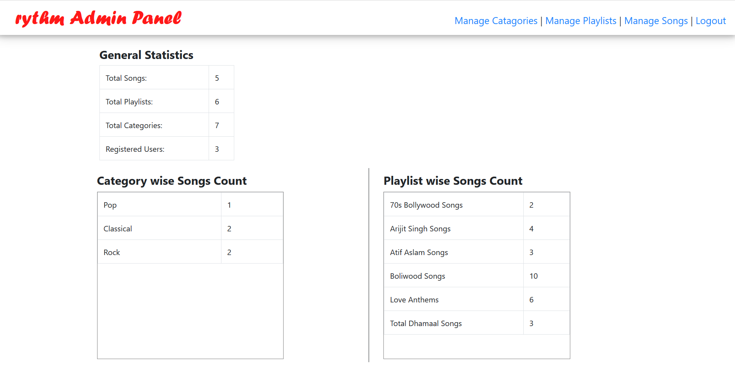
- Admin Home:-

- Manage Categories:-
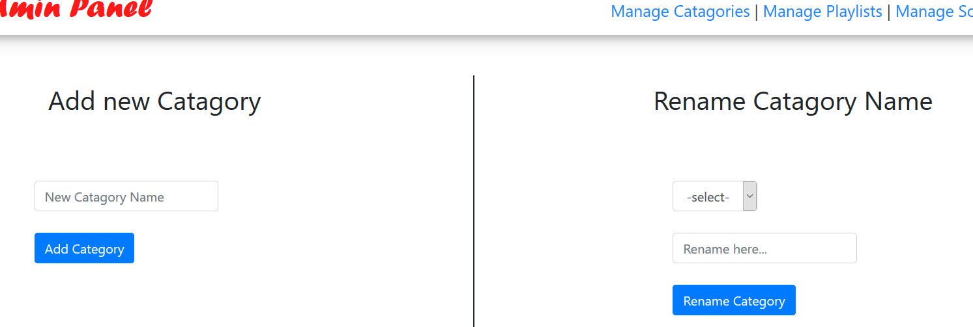

- Manage Playlists:-
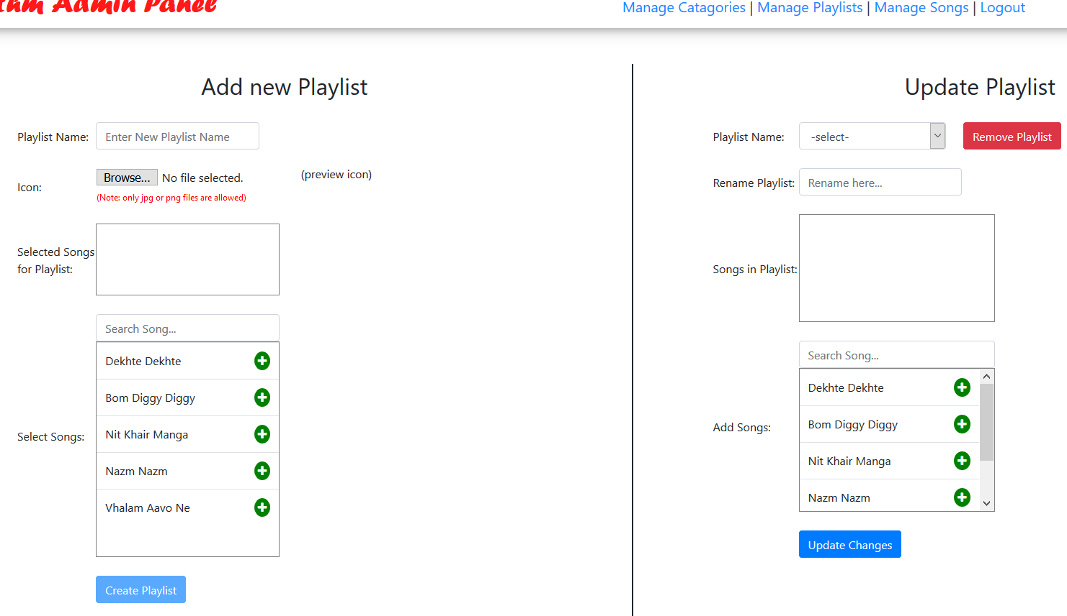
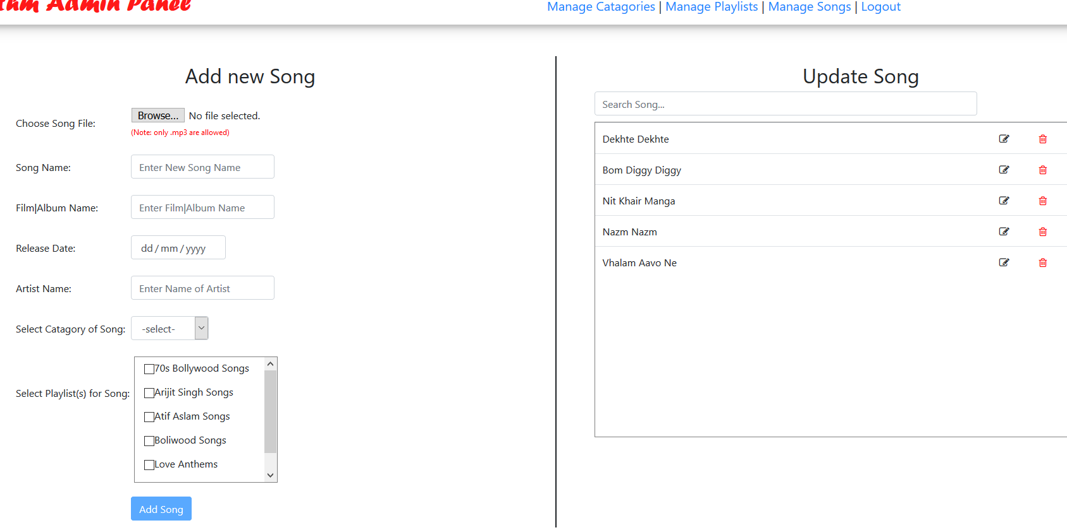
- Manage Songs:-

- Conformation:-
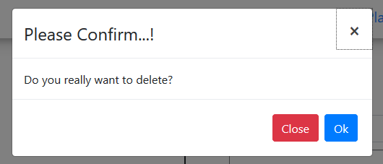
- Song Update Popup:-

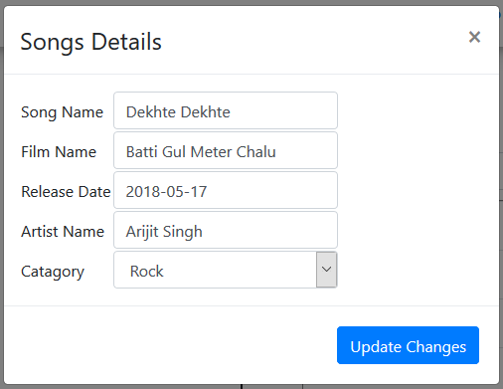

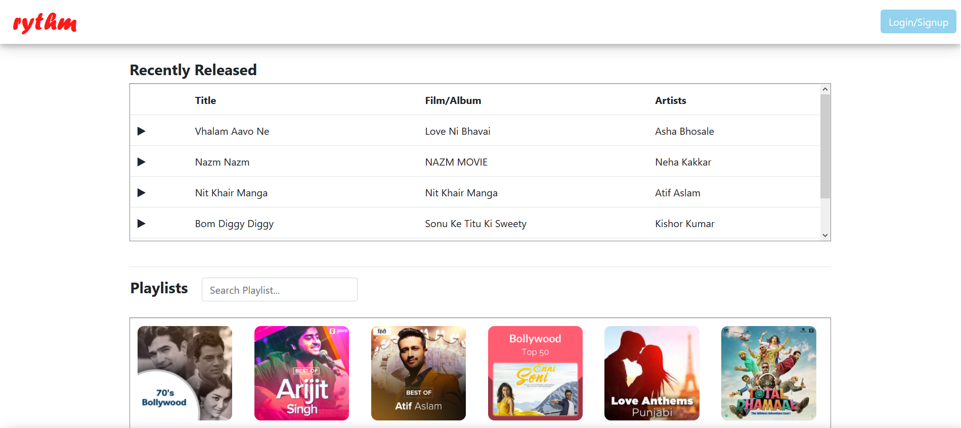
- Home:-

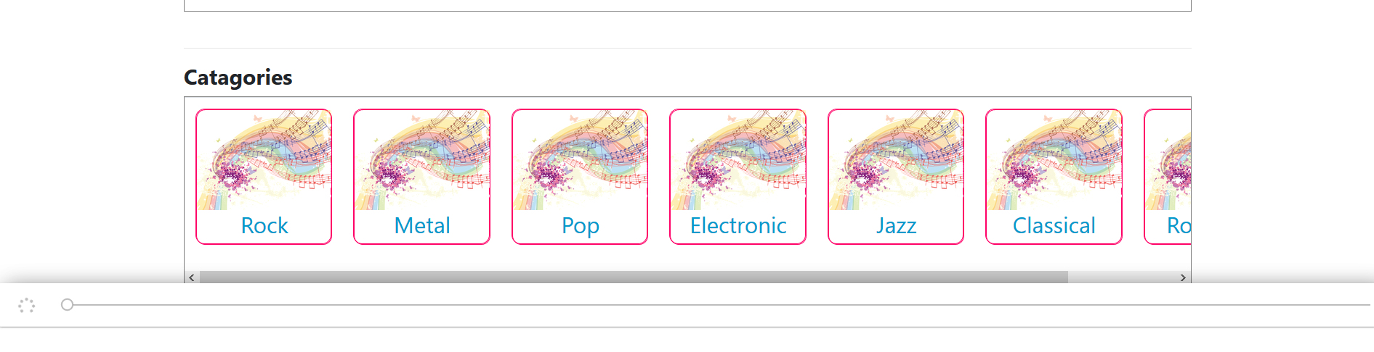

- All Songs of Playlist:-
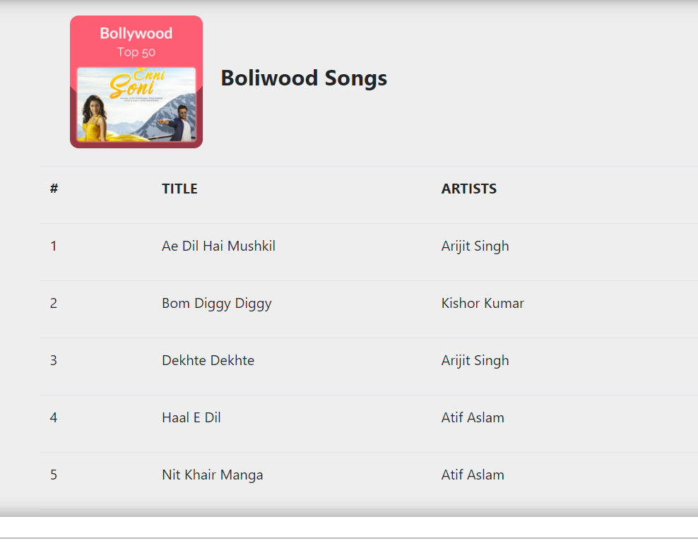(Without Login)
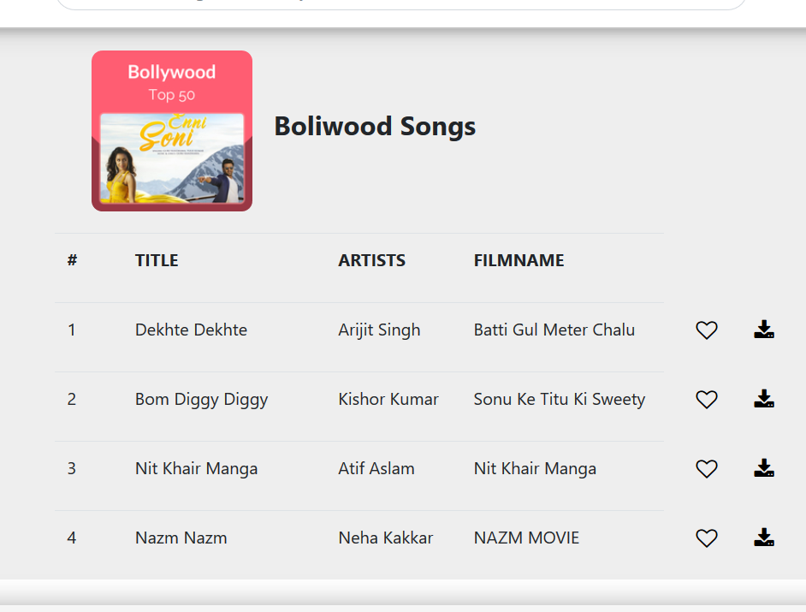(After Login)
- All Songs of Playlist:-
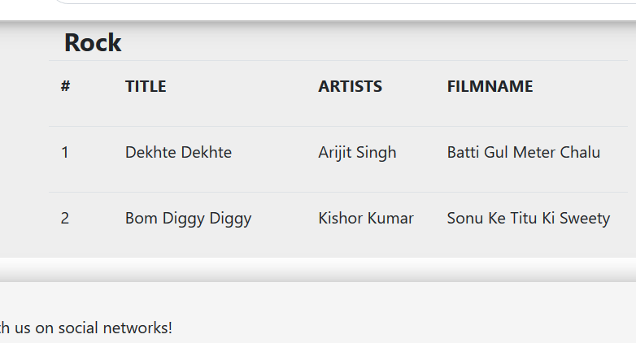(Without Login)
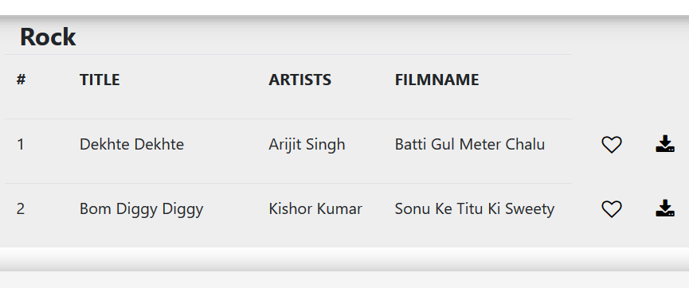(After Login)

- Like and Dislike Songs:-
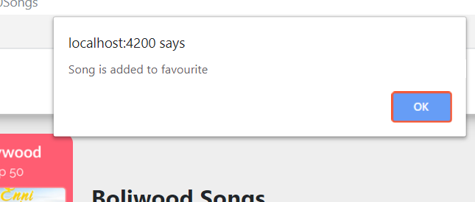(Liked)

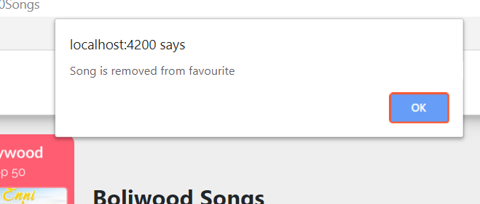(Disliked)

- Footer:-
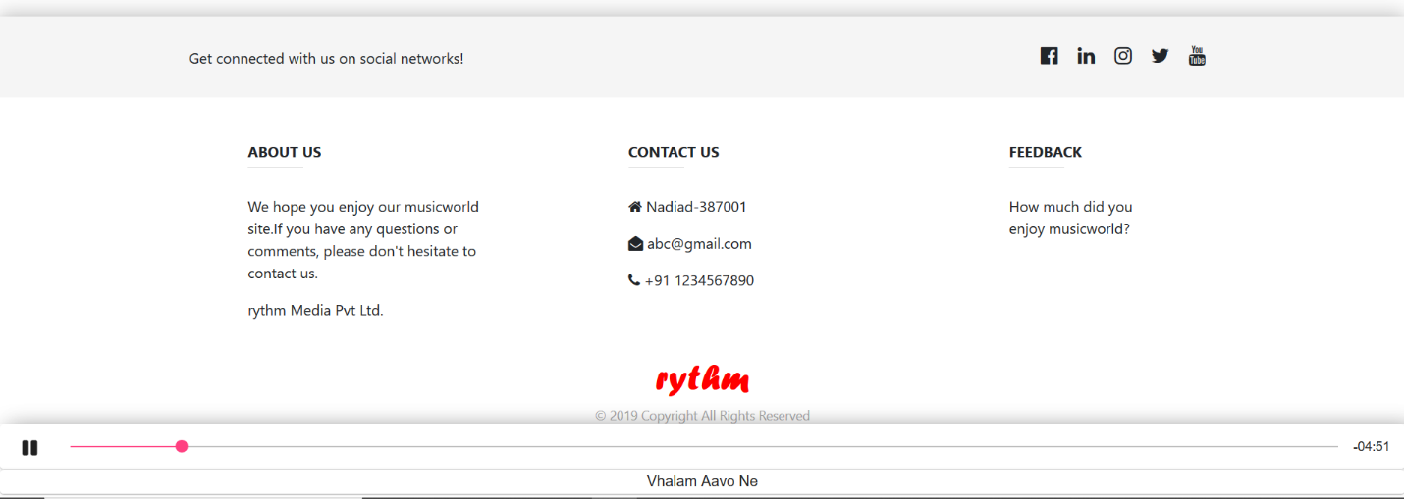

- My Favourites:-
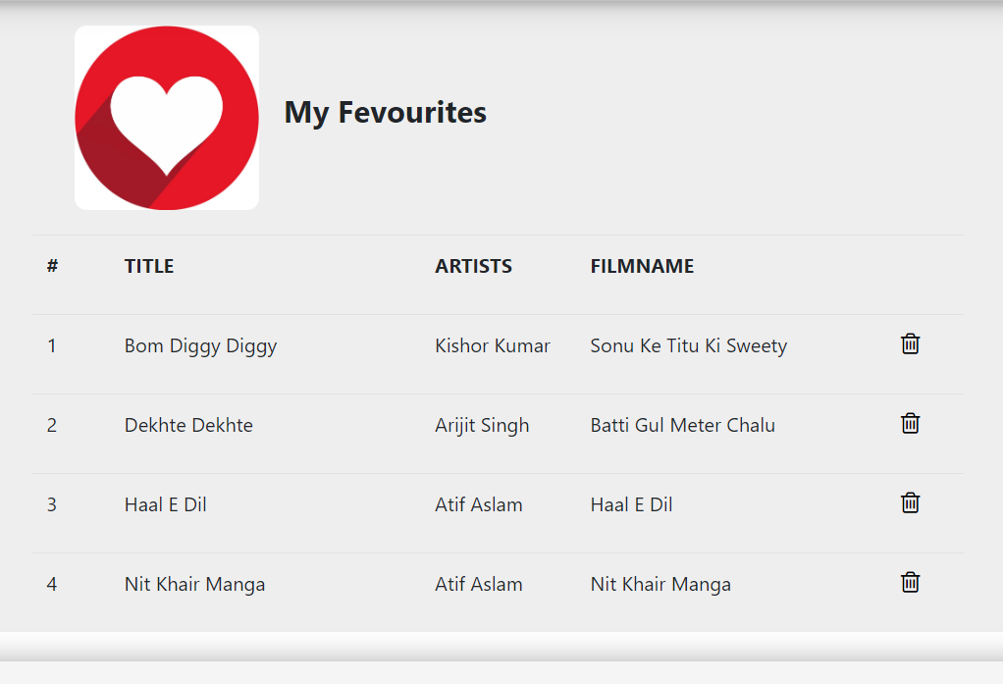
(After removing any song)
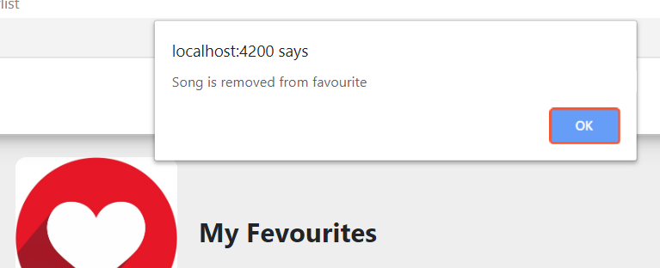

- Login:-
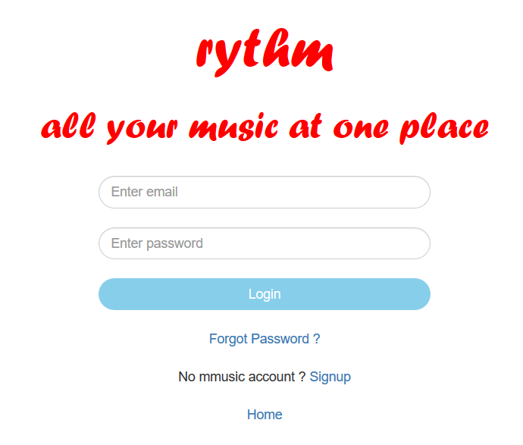

- After Login:-

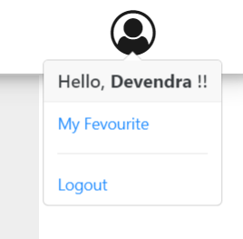

- OTP on User Email ID:-
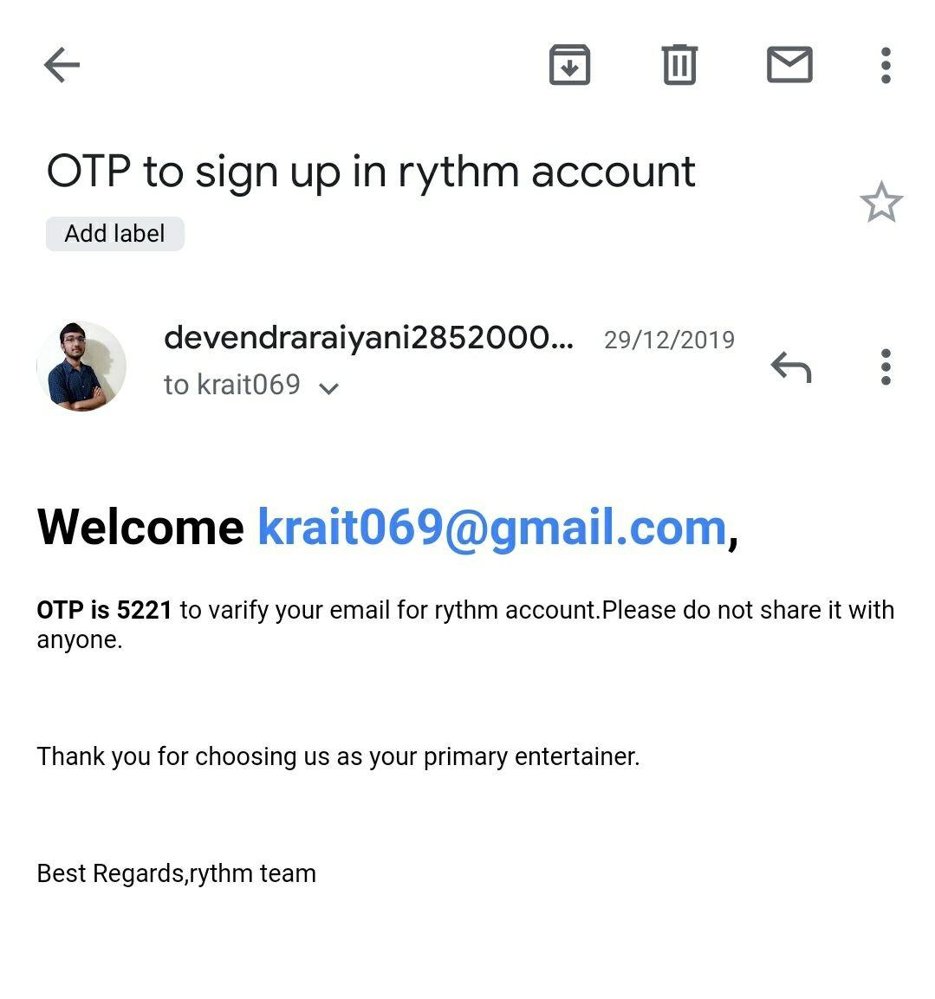

CONCLUSION
In this project, Admin User can manage songs, categories, playlists and view statistics like number of total songs, playlists with number of songs, categories with number of songs.
User can login, signup, logout and change password. By selecting any playlist song list will be displayed. By selecting any song from that list, song will be played and audio player will be displayed at the bottom of the window with song title. By pressing like button of particular song, that song will be added in My Favourite playlist of that user. By pressing download button .mp3 file will be downloaded.

LIMITATIONS
&
FUTURE EXTENSION
- Limitations:
- User can't play entire playlist.
- Song Queue is not there.

- Not Implemented Functionality:
- User can't create your own playlists.

- Future Extension:
- User can play entire playlist.
- User can create your own playlists.

BIBLIOGRAPHY
To build this project we have taken references from following websites,
- W3schools – https://www.w3schools.com/
- StackOverflow – https://stackoverflow.com/
- NpmJS – https://www.npmjs.com/
- Angular – https://angular.io/docs
- NodeJS – https://nodejs.org/en/docs/
- MongoDB – https://docs.mongodb.com/
- Tutorialspoint – https://www.tutorialspoint.com

